**Brain network study during resting states**

*Alessandro* TAGLIERI, *Davide* ZINGARO, *Yao* APPETI

University of Rome, MSc Data Science - Bioinformatics class 2020/2021, Group N° 8

**Introduction:**

*The goal this project is to analyze two datasets of EEG data and to prepare a report on their comparison. EEG data are recorded from 64 electrodes with subject at rest in eyes-open (EO) and eyes-closed (EC) conditions, respectively. These input files are in the following web pages:* [*https://physionet.org/content/eegmmidb/1.0.0/*](https://physionet.org/content/eegmmidb/1.0.0/) *. For this project we considered S038R01.edf and S038R01.edf files.*

*Analyses will span the following topics:*

1. *connectivity graphs*
2. *graph theory indices*
3. *motif analysis*
4. *community detection*

In Table 1 we’ve defined all task that we’ve done for the project. We’ve written also their complexity (as written in the track). To perform all task that we considered we use a Jupyter Notebook where we’ve written python code using several libraries, like netwrokX1, iGraph2, Louviain3, Infomap4, smallworld5, connectivipy6 and pyedflib7. The complete jupyter notebook is in the following GitHub repository: https://github.com/AlessandroTaglieri/Project_Bioinformatics/tree/main/NeuroScience

To execute correctly the project, it’s necessary to move two input files and *channels.txt* file in a directory named ‘data’. This directory must be allocated in the same path where you put the jupyter notebook.

**Part 1. Connectivity graph**

In this part, we were aimed to estimate functional brain connectivity among 64 channels. In order to do that, we used two types of Multivariate Autoregressive models: Partial Directed Coherence (PDC), Direct Transfer Function (DTF). The Multivariate Autoregressive (MAR) model characterizes interregional dependencies within data, specifically in terms of the historical influence one variable has on another. We used python implementation of Multivariate Autoregressive modes. From that implementation, we used methods that perform estimation using PDC, DTF. We were aimed to obtain a network with a density of 20% applying threshold. In order to find a threshold, we wrote a function that calculates it using the formula of the density of directed graphs. Applying that value of the threshold to the output of estimation gives us an adjacency matrix and we can build the target graph. We performed this procedure for both conditions. As shown in *figure 1* (using DTF) and in *figure 2* (using PDC), in both conditions (EO and EC), graphs are still connected.

In addition, we had a task where we needed to consider subset with 19 electrodes. We needed again to repeat process that was described above but in addition we were required to filter out values that are not significantly different from 0 (PDC (i, j) ≠ 0 with p < 5%). In the python implementation there is a method that is written to solve that. As the result we obtained adjacency matrix that can be used for visualizing a graph. *Figure 3* illustrates graphs obtained with 19 channels. In this figure where we are considering first condition (EO), we see that we have 3 disconnected nodes while in the second condition we have 1 disconnected node. They are different in both cases.

Using cartesian coordinates of channels, we made topological representation of the network. We performed it to both variants of the graphs that we had with 64 and 19 channels. Topological representation of 64 channels with density 0.05 is shown in *figure 4* (using PDC) and for 19 channels it is shown in *figure 5* (using DTF). When we are considering 64 channels with density 0.05 in condition when eyes are closed, we see less connections in right-side of central lobe in comparison with condition when eyes are opened. And with opened eyes condition there are more outgoing edges from frontal lobe to parietal lobe in comparison with closed eyes condition. On the contrary, in closed eyes condition we can see that we have more outgoing edges from parietal lobe to frontal lobe than in opened eyes condition. In *figure 4,* we can see that in opened eyes case there are less connections in frontal lobe and on the left side in comparison with closed eyes case.

**Part 2. Graph theory indices**

In the second part, we were aimed to compute binary global (clustering coefficient, path length) and local (degree, in/out degree) graph indices. In order to perform this task, we started from the DTF graph generated in the previous point. Results of the global graph indices are shown in *Table 2*, in which we compared the values obtained both in the eyes-open (EO) condition and in the eyes-closed (EC) condition. Then, we observed the global graph indices through PDC estimator (*Table 3*). Observing these two tables, we can notice a low average clustering coefficient and a short average path length in both eyes-open and eyes-closed conditions. Results of the local graph indices are shown in *Table 4* and in *Table 5*, in which we summarized the top 10 nodes sorted by highest degree in EO and EC condition, respectively. We computed these values using the DTF estimator. The node that has the greater degree, it’s the more important for the whole system. In a directed graph, as in our case, the degree can be split into in-degree and out-degree. Observing the tables related to the local indices, we can notice that the degree distribution when the subject has his eyes open is pretty much similar to the other case.

Then, performing another task, we plot a topographical representation of local indices using cartesian coordinates of EEG channels*. Figure 8* represents in-degree network, *Figure 9* stays for out-degree and *figure 10* about degree indices. We highlighted in light-blue color the 10 highest degree nodes. We can observe that, in both cases, the nodes with high in-degree values are homogeneously located in the different brain lobes, with a slight tendency to the right hemisphere; instead, the highest out-degree nodes are mostly located in the frontal/parietal lobe, with a high tendency to the left hemisphere.

In addition, we tried to compute the small-world organization of our network. A graph has a small-world property if it is characterized by a high clustering coefficient and a short path length. The main mechanism to construct small-world networks is the Watts-Strogatz model. We used this model to compute a small-world network with same number of nodes and same average degree of our directed graph. Small-world properties are found in many real-world phenomena, including biological and neural networks. We started from a regular ring lattice graph with N vertices and k edges per vertex; then, we rewire each edge at random with probability β. We built three graphs with probability β equal to 0, 0.25 and 1, respectively; both for EO and EC subject-condition (*Figure 6* and *Figure 7*). When β=0, we obtain a completely regular lattice graph, with no rewiring and each node connected to k of its neighbors. If no edge is rewired, we expect that the distances between each pair of nodes would be long. Also, if k is large enough, the ring lattice starts to form many triangles. So, it is characterized by a high clustering coefficient and a long path length. With β=1, we rewire every single edge; so, we obtain a completely random graph with short path length and small clustering coefficient. With β=0.25, we obtain a small-world network. Some edges are rewired; so, the distances between nodes are reduced but a high clustering coefficient is maintained. Hence, we can notice that the average clustering coefficient and the shortest path of a small world network depend on the parameters k and β. We tried to quantify network small-worldness by a small-coefficient, σ, calculated by comparing clustering and path length of a given network to an equivalent (directed) random network with same degree on average. If σ coefficient is greater than 1, the network presents small-world properties. ​Results of the ​σ coefficient are 3.89 (in the case of Eyes-Opened) and 2.073 (in the case of Eyes-Closed), using the DTF estimator. W can notice that ​σ coefficient values are greater than 1. We obtained a small-world network in both cases. However, this metric is known to perform poorly because it is influenced by the network size​.

**Part 3. Motif analysis**

In this third part we are aimed to analyse motifs presence in the network. Network motifs are sub-graphs that repeat themselves in a specific network. Each of these sub-graphs, defined by a particular pattern of interactions between vertices, may reflect a framework in which particular functions are achieved efficiently. Indeed, motifs are of notable importance largely because they may reflect functional properties. We considered configurations which contain 3 nodes. There are possible 13 configurations. We implemented our function that counts their frequencies in python. Additionally, we needed to find their significance. In order to do that we needed to consider also random graph with the same number of nodes and density. We performed Monte Carlo simulations to get mean and standard deviation of frequencies of configurations in random graphs. We needed these two values in order to count Z values of configurations. Larger value of Z means that its significance is larger. Results of all frequencies and Z values for each configuration are shown in *Table 7*. Among 13 configurations seven of them have high Z-value in condition where eyes are opened. Especially, Z-value of configuration when 3 nodes construct a triangle where they go in both directions (A->B->C->A->C->B->A), it has really small frequency in both cases. Configuration ‘A->B<-C’ has the highest frequency and quite high Z-value in both cases. Configurations that have Z-value less than -0.9 can be considered as anti-motifs. From first condition we have 3 anti-motifs. Two of them are also anti-motifs for second configuration however one of them is not the same and it is configuration that was not nor motif or anti-motif in first condition.

We performed also topological representation of network considering only configuration ‘A->B<-C’. In order to perform this task, we wrote a procedure that takes in consideration only this configuration. Since it has the highest frequency it covers all the nodes. In order to see the difference views, we used graphs with density 0.05. Graphs are represented in *Figure 11*. When eyes are closed there are few edges in nodes in right central lobe.

In parieto-occipital scalp region we selected one channel to consider and show in which motifs they are involved. This is ‘Po8’. We have four configurations in eyes opened and eight in case when eyes are closed. Motifs related to node ‘Po8’ are shown in *figures ​12* and *figures 13*.

**Part 4. Community detection**

Over the years, many algorithms are developed for understanding brain connectivity and information flows using graph theory. However, we will see here how Louvain and Infomap algorithms behave with two analyzed datasets containing EEG data.

The main research question regarding this part is making inference by seeing how different parts of brains can be grouped by using different techniques that are information-based (Infomap algorithm) or based on the modularity of the network (Louvain). Clustering algorithms has the goal to capture the intuitive notion that nodes should be connected to many nodes in the same community (intra-cluster density) but connected to few nodes in other communities (inter-cluster sparsity).

*Figures 14, 15* show community structures as mentioned in the previous sections, for two different conditions: eyes-closed (EC), and eyes-opened (EO). Colored vertices correspond to the identified communities and their location according to the channel labels. Tables 8 and 9 show the composition of the communities obtained by Louvain algorithm. By observing the results of the modularity-based algorithm, we see that communities in the results of the Louvain algorithm in both states look quite differentiable. Moreover, the infomap algorithm created one community in the EC state. While, in the EO state, a lot of nodes from frontal, right temporal, parietal and occipital parts are labeled as part of the bigger community(region) of the brain. While comparing the execution times of the algorithms, Louvain was the most efficient.

**References:**

**1 –** [**https://networkx.org**](https://networkx.org)Python package for the creation, manipulation, and study of the structure, dynamics, and functions of complex networks:

**2 –** [**https://igraph.org**](https://igraph.org) Collection of network analysis tools with the emphasis on efficiency, portability and ease of use

**3 –https://github.com/taynaud/python-louvain :** This module implements community detection with Louvian method

**4 –https://mapequation.github.io/infomap/python/ :** This module implements community detection with INFOMAP method

**5 -** [**https://github.com/benmaier/smallworld**](https://github.com/benmaier/smallworld)Functions for estimating the small-world-ness of graphs

**6 -** [**https://github.com/dokato/connectivipy**](https://github.com/dokato/connectivipy) **:** module for connectivity analysis

**7 -https://pyedflib.readthedocs.io/en/latest/ :** python library to read/write EDF+/BDF+ files based on EDFlib.

**Figures and Tables**

Table 1. The list of task performed in this project

|  |  |
| --- | --- |
| **Task** | **Class** |
| **1.1** | Mandatory |
| **1.2** | A |
| **1.4** | D |
| **1.5** | C |
| **2.1** | Mandatory |
| **2.2** | D |
| **2.3** | B |
| **2.5** | B |
| **3.1** | Mandatory |
| **3.2** | C |
| **3.3** | C |
| **4.1** | Mandatory |
| **4.2** | B |
| **4.3** | C |

Figure 1. Network with a density 20% applying threshold: using DTF estimator

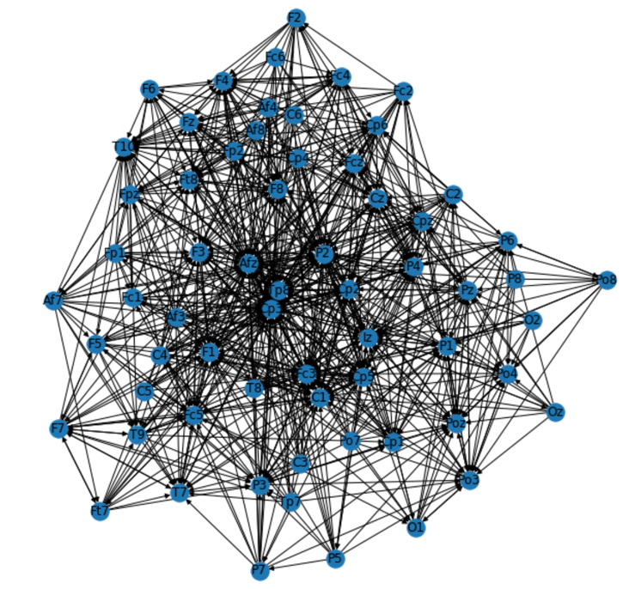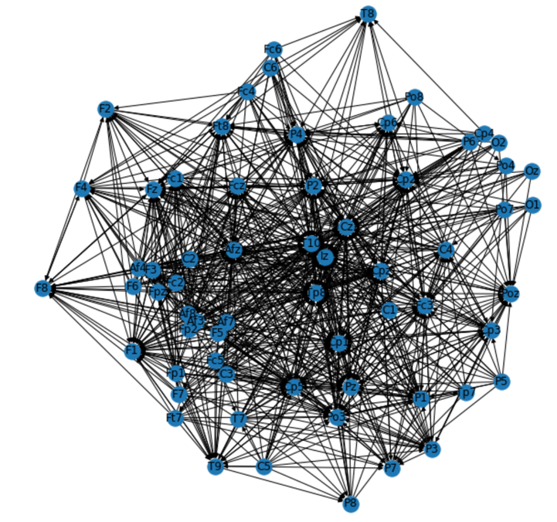

Eyes-Opened Eyes-Closed

Figure 2. Network with a density 20% applying threshold: using PDC estimator

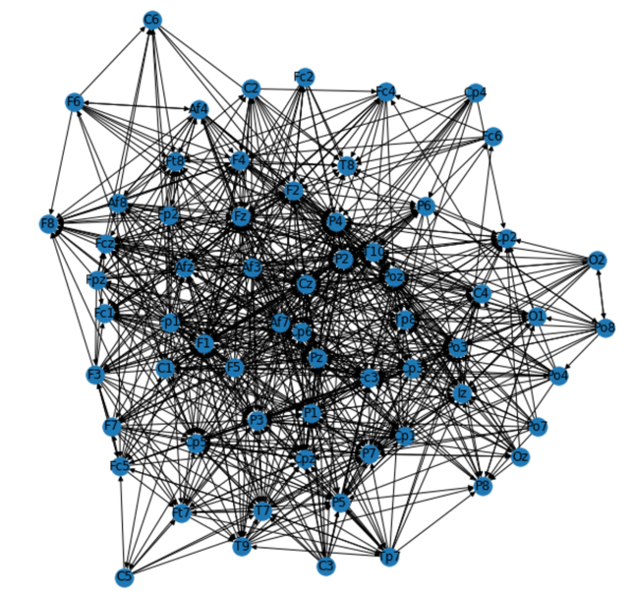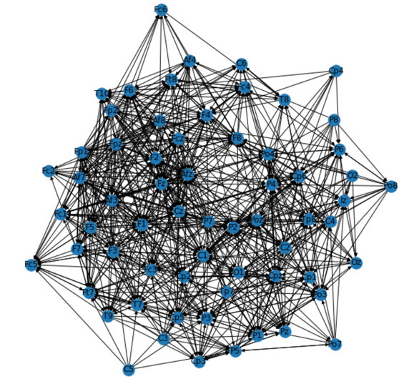

Eyes-Opened Eyes-Closed

Figure 3. DTF of 19 suggested channels

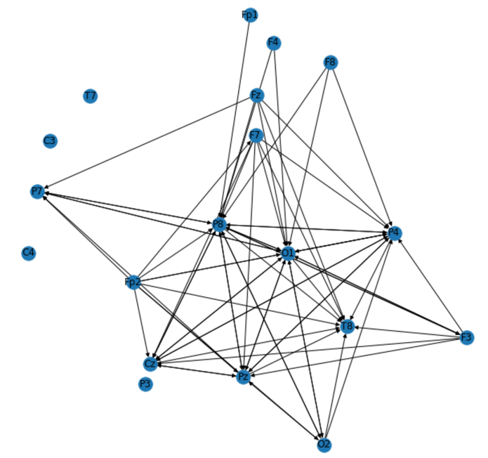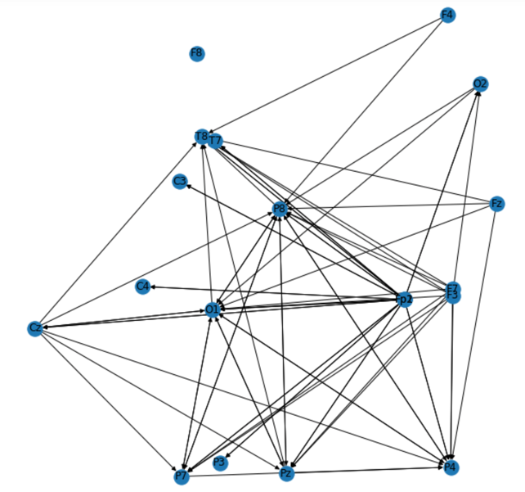

Eyes-Opened Eyes-Closed

Figure 4. Topographical representation of the PDC networks with density 0.05 using cartesian coordinates

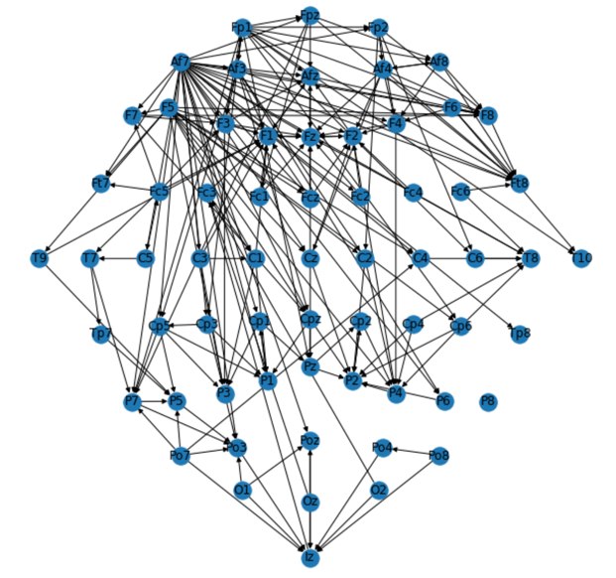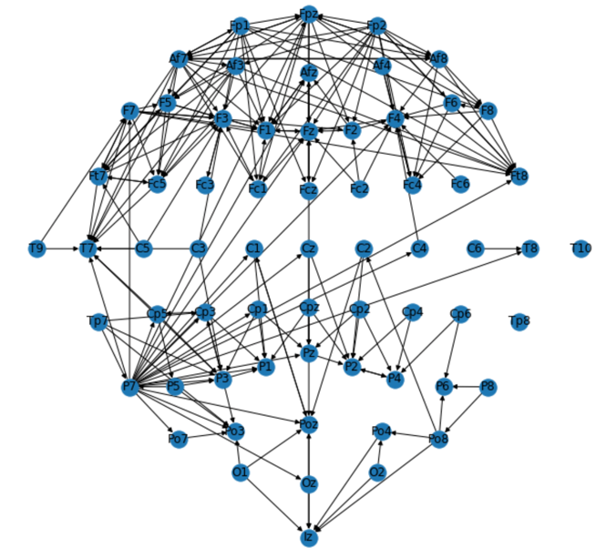

Eyes-Opened Eyes-Closed

Figure 5. Topographical representation of the DTF network with density 0.02 (< 5%) for 19 channels using cartesian coordinates

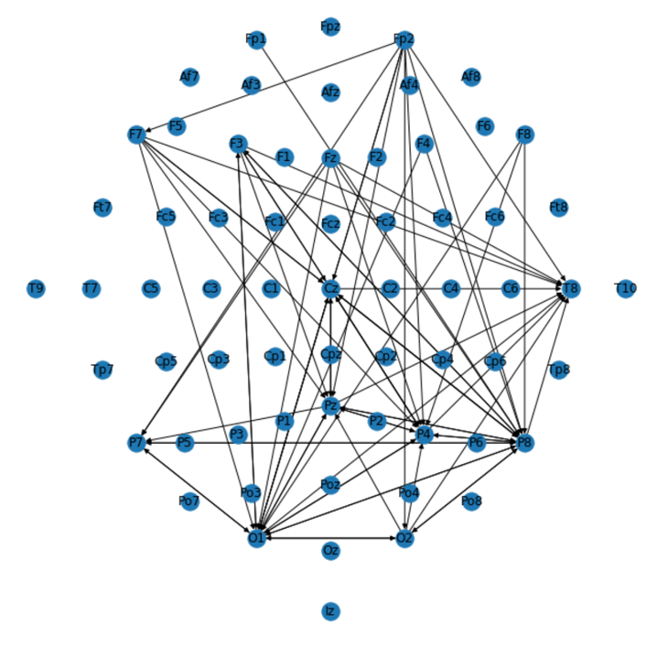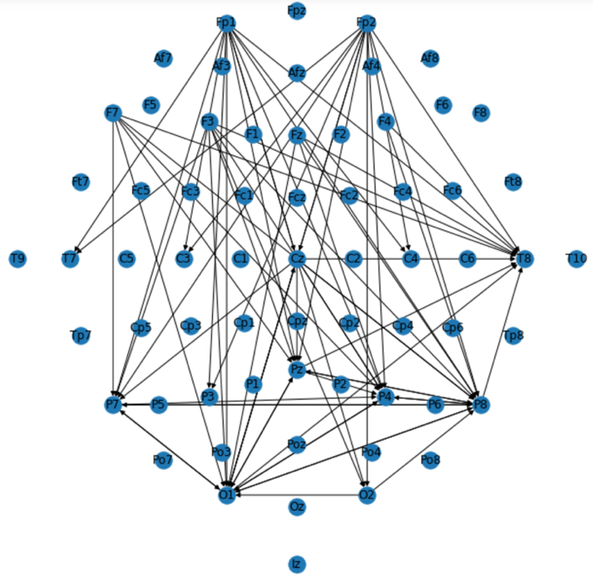

Eyes-Opened Eyes-Closed

Table 2. Binary global graph indices - TDF

|  |  |  |
| --- | --- | --- |
| **Condition** | **Index** | **TDF** |
| Eyes-open | Average clustering coefficient | 0.409 |
| Eyes-open | Average path length | 0.843 |
| Eyes-close | Average clustering coefficient | 0.41 |
| Eyes-close | Average path length | 1.556 |

Table 3.  Binary global graph indices - PDC

|  |  |  |
| --- | --- | --- |
| **Condition** | **Index** | **PDC** |
| Eyes-open | Average clustering coefficient | 0.326 |
| Eyes-open | Average path length | 2.673 |
| Eyes-close | Average clustering coefficient | 0.36 |
| Eyes-close | Average path length | 1.987 |

Table 4.  Local indices DTF – eyes opened

|  |  |  |  |  |  |  |  |
| --- | --- | --- | --- | --- | --- | --- | --- |
| **Node** | **In - Degree** |  | **Node** | **Out - Degree** |  | **Node** | **Degree** |
| T10 | 60 |  | Cp5 | 21 |  | Iz | 68 |
| Iz | 60 |  | Afz | 20 |  | Cz | 61 |
| Tp8 | 56 |  | Cp3 | 19 |  | Tp8 | 61 |
| Cz | 47 |  | Af7 | 19 |  | T10 | 60 |
| P2 | 38 |  | Fc5 | 18 |  | Cp5 | 49 |
| Cp2 | 33 |  | Fc3 | 18 |  | Cp1 | 49 |
| Cp1 | 32 |  | Fp1 | 18 |  | Afz | 49 |
| Fz | 30 |  | Fp2 | 18 |  | Fc3 | 47 |
| Fc3 | 29 |  | Af3 | 18 |  | P2 | 46 |
| Afz | 2 |  | F5 | 18 |  | Cp2 | 44 |

Table 5.  Local indices DTF – eyes closed

|  |  |  |  |  |  |  |  |
| --- | --- | --- | --- | --- | --- | --- | --- |
| **Node** | **In - Degree** |  | **Node** | **Out - Degree** |  | **Node** | **Degree** |
| Afz | 53 |  | Cp3 | 19 |  | Afz | 71 |
| Cp3 | 49 |  | Fpz | 19 |  | Cp3 | 68 |
| P2 | 48 |  | Af3 | 19 |  | P2 | 62 |
| Tp8 | 46 |  | Pz | 19 |  | Tp8 | 52 |
| Fc3 | 38 |  | Fc5 | 18 |  | Fc3 | 51 |
| C1 | 32 |  | Fp1 | 18 |  | C1 | 46 |
| F1 | 31 |  | Afz | 18 |  | Iz | 44 |
| Iz | 28 |  | P1 | 17 |  | Cp2 | 40 |
| T10 | 26 |  | Cp5 | 16 |  | F1 | 39 |
| Cp2 | 25 |  | Af7 | 16 |  | F3 | 37 |

Figure 6. DTF Small-World network (EO)

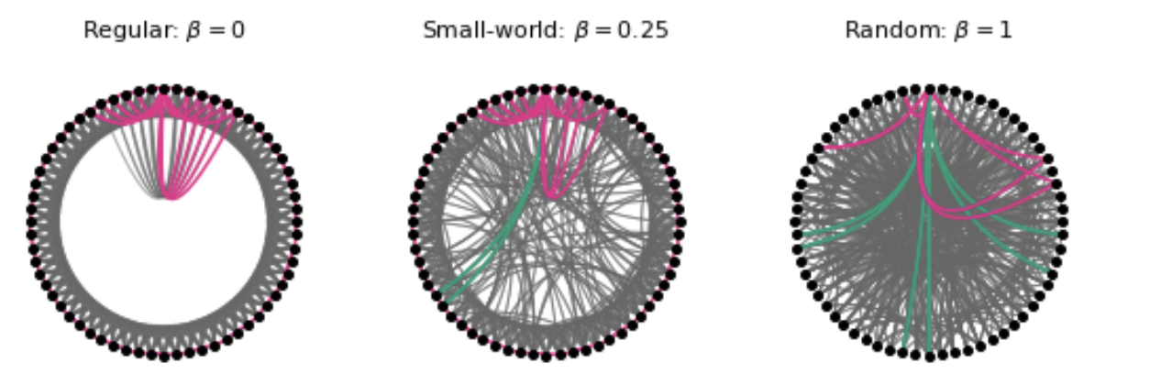

Figure 7. DTF Small-World network (EC)

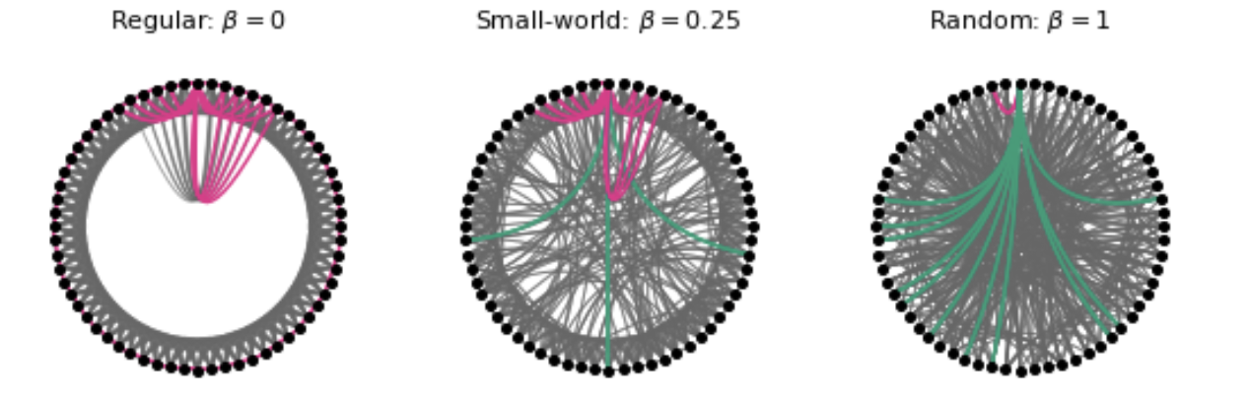

Figure 8. DTF In-Degree

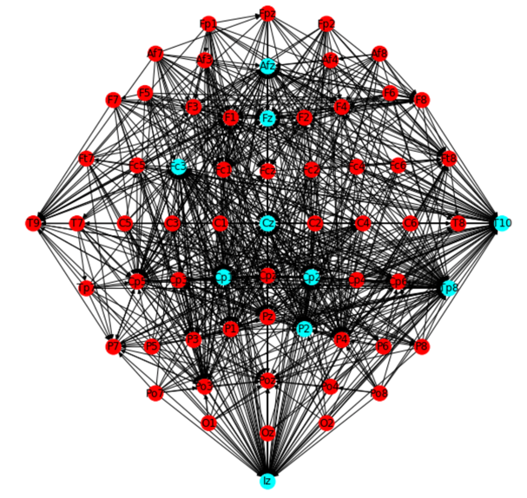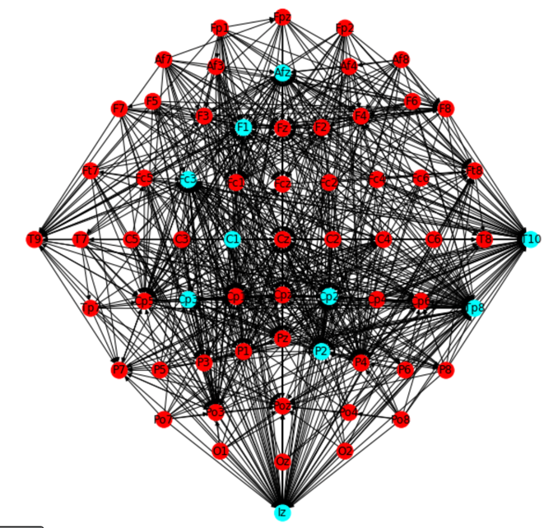

Eyes-Opened Eyes-Closed

Figure 9. DTF Out-Degree

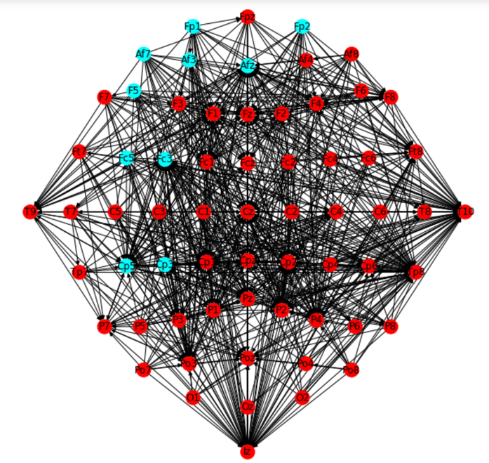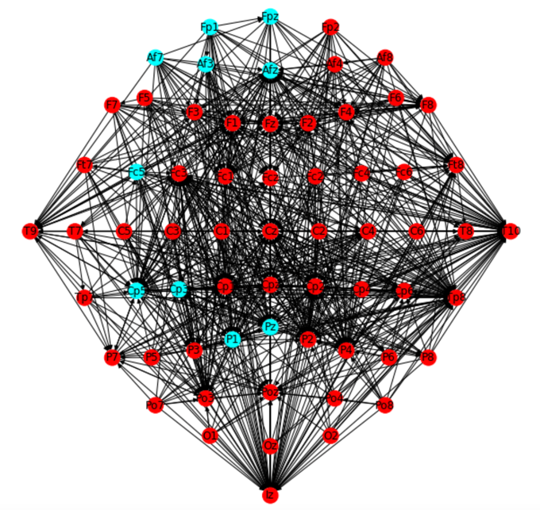

Eyes-Opened Eyes-Closed

Figure 10. DTF Degree

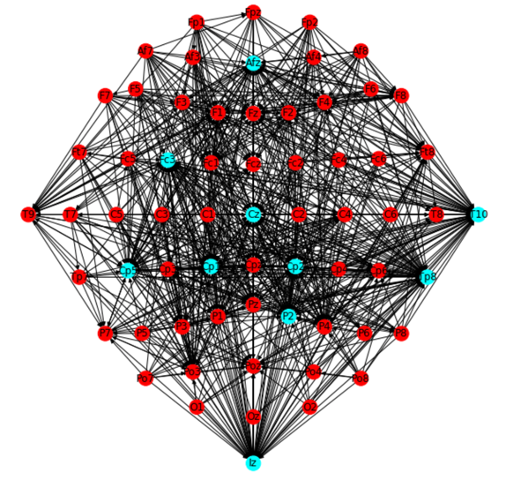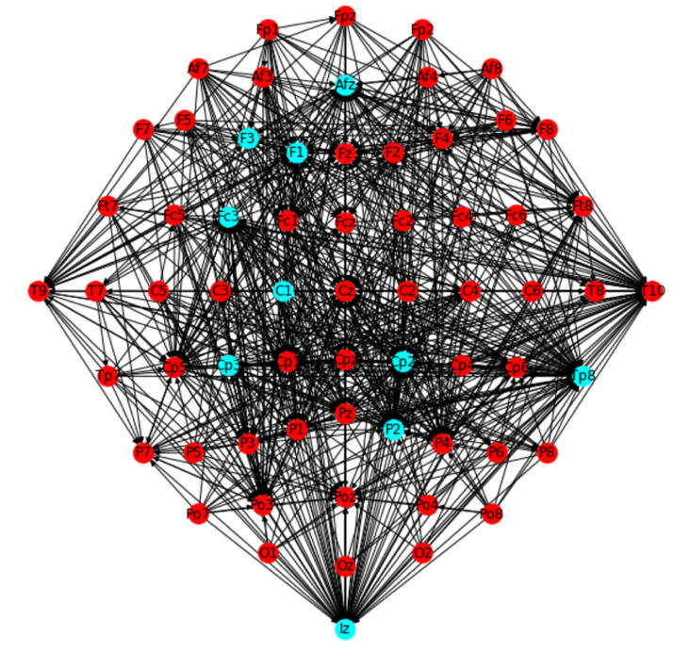

Eyes-Opened Eyes-Closed

Table 6.  Frequencies and Z-values of motifs in network

|  |  |  |  |  |  |
| --- | --- | --- | --- | --- | --- |
| **CONFIGURATION** | **Graphic representation** | **Frequency**  **(EO)** | **Z**  **(EO)** | **Frequency**  **(EC)** | **Z (EC)** |
| **A->B->C** |  | 6536 | -3.178391 | 7068 | -2.679838 |
| **A->B->C->A** |  | 376 | -3.653741 | 651 | -0.114797 |
| **A->B->C->B** |  | 2631 | 5.559106 | 3356 | 9.382549 |
| **A->B->C->A->C** |  | 371 | 1.045722 | 616 | 6.461059 |
| **A->B->C->A->C->B** |  | 3883 | -0.455113 | 7259 | 4.110619 |
| **A->B->C->A->C->B->A** |  | 58 | 29.151113 | 72 | 39.942987 |
| **A->B->C->B->A** |  | 355 | 3.907596 | 578 | 9.181598 |
| **A->B<-C** |  | 11879 | 20.547587 | 9278 | 16.090764 |
| **A->B<-C->A** |  | 3660 | 11.629491 | 3123 | 11.182618 |
| **A->B<-C->A->C** |  | 516 | 9.463630 | 649 | 14.788225 |
| **A<-B->C** |  | 4812 | 0.003570 | 4475 | -1.122909 |
| **A<-B->C->B** |  | 900 | -3.601386 | 1367 | -1.077191 |
| **A<-B->C->A->C** |  | 1040 | 26.995669 | 1191 | 34.00327 |

Figure 11. Topographical representation of the networks involved in A -> B <- C

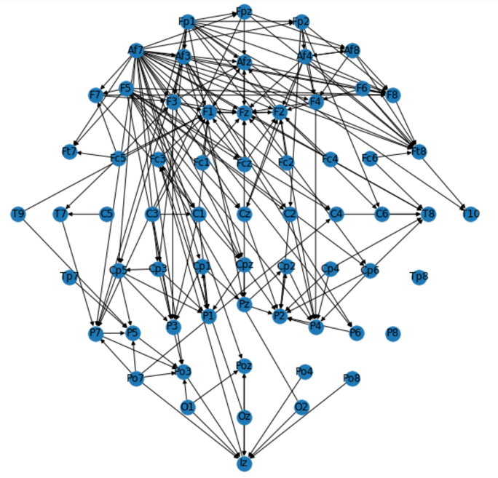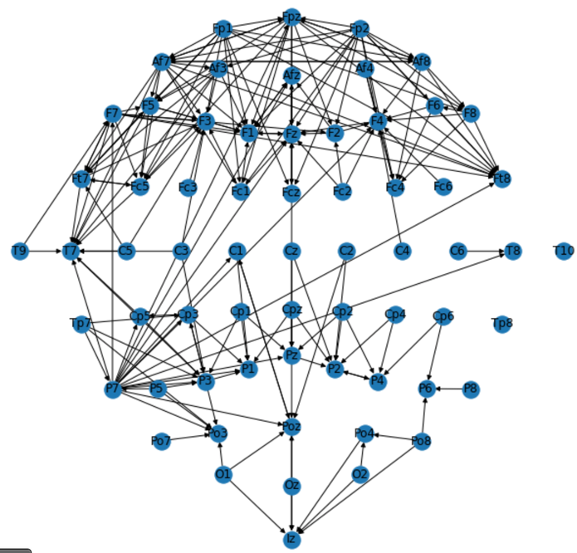

Eyes-Opened Eyes-Closed

**Figure 12.** Paretio-Occipital - EO

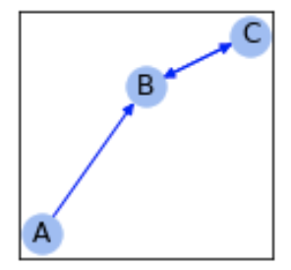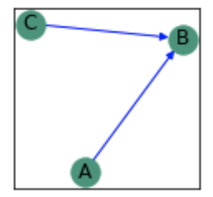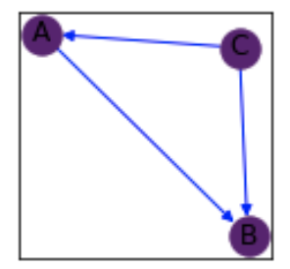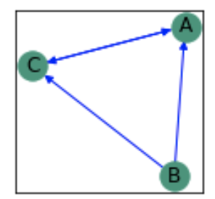

**Figure 13.** Paretio-Occipital - EC

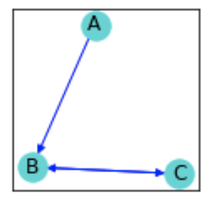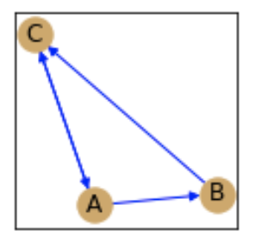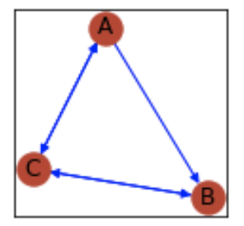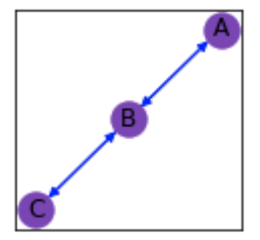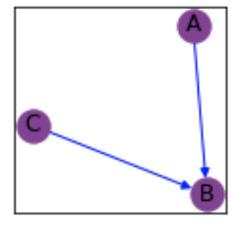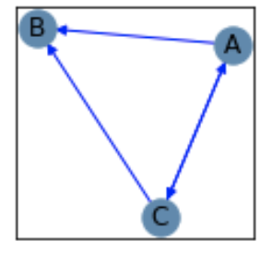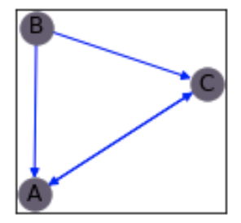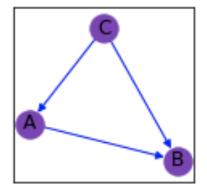

**Table 7.** Composition of communities using Louvian algorithm (EO)

|  |  |
| --- | --- |
| **Size** | **Composition of communities** |
| 22 | 'Fc1', 'Fcz', 'Fc2', 'Fc4', 'C2', 'C6', 'Fp1', 'Fpz', 'Fp2', 'Af7', 'Af3', 'Afz', 'Af4', 'Af8', 'F3', 'F1', 'Fz', 'F2', 'F4', 'F6', 'F8', 'Ft8' |
| 22 | 'Fc5', 'Fc3', 'C5', 'C3', 'C1', 'C4', 'Cp5', 'Cp3', 'Cp1', 'Cpz', 'F7', 'F5', 'Ft7', 'T7', 'T9', 'Tp7', 'P7', 'P5', 'P3', 'P1', 'Pz', 'Po3' |
| 20 | 'Fc6', 'Cz', 'Cp2', 'Cp4', 'Cp6', 'T8', 'T10', 'Tp8', 'P2', 'P4', 'P6', 'P8', 'Po7', 'Poz', 'Po4', 'Po8', 'O1', 'Oz', 'O2', 'Iz' |

**Table 8.** Composition of communities using Louvian algorithm (EC)

|  |  |
| --- | --- |
| **Size** | **Composition of communities** |
| 19 | 'Fc5', 'Fc3', 'Fc1', 'C5', 'C3', 'Fp1', 'Af7', 'Af3', 'F7', 'F5', 'F3', 'F1', 'Ft7', 'T7', 'T9', 'Tp7', 'Tp8', 'P7', 'P3' |
| 16 | 'Fcz', 'Fc2', 'Fc4', 'Fc6', 'Fpz', 'Fp2', 'Afz', 'Af4', 'Af8', 'Fz', 'F2', 'F4', 'F6', 'F8', 'Ft8', 'T10' |
| 15 | 'C1', 'Cz', 'C2', 'C4', 'C6', 'Cp5', 'Cp3', 'Cp1', 'Cpz', 'Cp2', 'Cp4', 'Cp6', 'T8', 'P2', 'P4' |
| 14 | 'P5', 'P1', 'Pz', 'P6', 'P8', 'Po7', 'Po3', 'Poz', 'Po4', 'Po8', 'O1', 'Oz', 'O2', 'Iz' |

**Figure 14.** Communities detected by Louvian algorithm

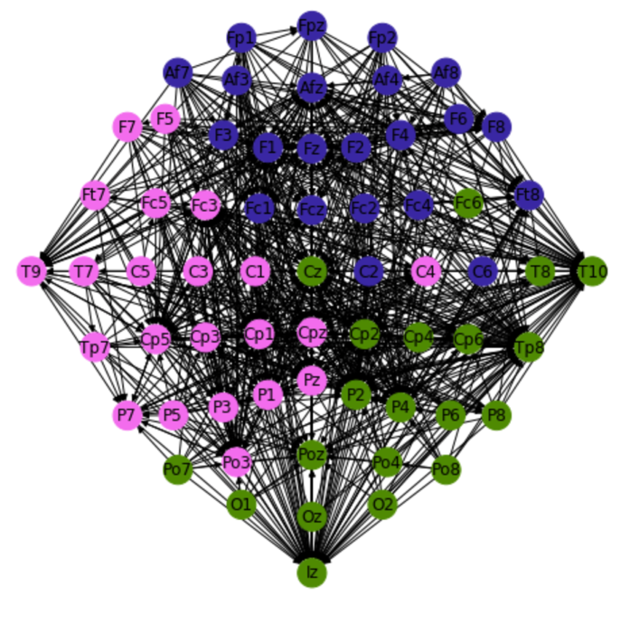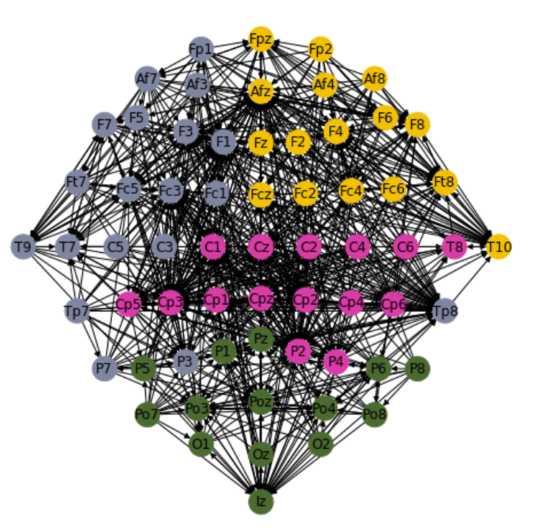

Eyes-Opened Eyes-Closed

**Figure 15.** Communities detected by InfoMap algorithm

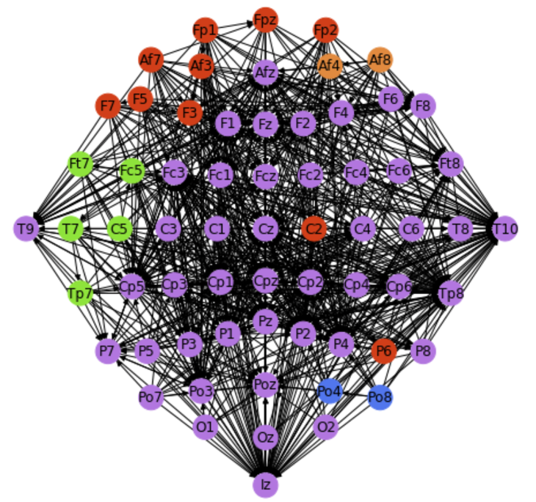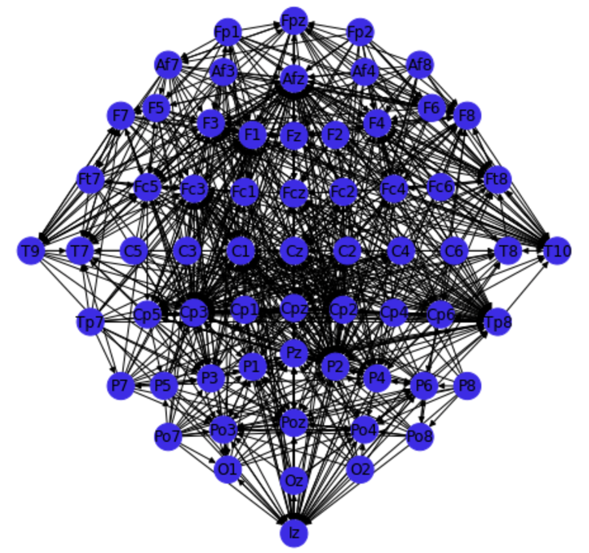

Eyes-Opened Eyes-Closed